Robust Dynamic Latent Variable Model for Dynamic Process monitoring with Missing Data in Cyber-Physical Systems
Le Zhou, Lixinqian Yu, Beiping Hou, Hongbo Zheng, Zheng-Guang Wu

Abstract: Although remarkable studies on dynamic process modeling and monitoring in cyber-physical systems have been conducted, there are still several limitations to these approaches, rendering them unsuitable for practical applications. Firstly, the common dynamic models are built based on complete data, which means that their modeling performance usually deteriorates when there are missing measurements. Secondly, practical data often exhibits more complex characteristics, such as non-stationary and non-Gaussian noises. Therefore, a robust dynamic latent variable model is proposed to address the challenges of dynamic process modeling and monitoring in complex measurement environments with missing values. The proposed method effectively handles non-Gaussian noises and recursively estimates missing values, thus enhancing the monitoring performance within the dynamic latent variable modeling framework. Finally, the feasibility and superiority of the proposed method are evaluated through a numerical example and a real wastewater treatment case, demonstrating its effectiveness and practicality in real-world scenarios.
Key Words: Missing values, Process monitoring, Robust dynamic latent variable models, EM algorithm

- Introduction
As industrial facilities and sensor technologies are continuously upgrading in the cyber-physical systems (CPS), the reliability and security of industrial processes have gained increasing significance. Consequently, the process monitoring method has been extensively developed by the deployment of artificial intelligence techniques in the field of process control over the last few decades.[1] Among them, data-based multivariate statistical process monitoring (MSPM) offers an easy-to-implement architecture in CPS without precise empirical knowledge and physical models [1-3]. Based on these models, a low-dimensional variable space is built to extract the essential features of the dataset in the traditional MSPM such as principal component analysis (PCA), partial least squares (PLS), and so forth [4-8]. Besides, the validity of these models and their extensions have also been proven in fault detection, isolation and root cause diagnosis [9].
However, traditional modeling methodologies in CPS focused too much attention on the cross correlations of the data. Actually, the dynamic relationship, which is also termed as auto-correlation, is another essential characteristic of the process data. To resolve dynamic modeling, Ku et al. [4] extracted auto-correlations by constructing an augmented matrix based on PCA, which was called dynamic PCA (DPCA) model. Furthermore, an indirect DPCA based on a consistent DPCA algorithm was introduced by Li and Qin [10]. Due to the ability to model the relationship between two datasets, canonical variate analysis (CVA) and PLS were also able to predict the future variables in the data and were used for dynamic modeling, respectively [11-12].
In spite of the proven ability of the above models to extract auto-correlations, they leave the cross correlations un-modeled. To incorporate both the static and dynamic relationship, Wen et al. [13] proposed a new probabilistic framework named data-based linear gaussian state-space model (LGSSM), which was also suitable to deal with datasets contaminated by stochastic noises. Besides, a novel method called dynamic latent-variable (DLV) modeling has been proposed by Li et al [14]. The method applied the structured DPCA algorithm and a vector autoregressive (AR) model to build DLVs, as well as performing PCA to illustrate cross correlations. Furthermore, Zhou et al. [15] designed an autoregressive DLV (ARDLV) model, which built a low-dimensional subspace for DLVs and the developed structure can concurrently extract the auto-correlations and cross correlations. Hence, it is more appropriate for dynamic process monitoring.
The above methods are usually constructed based on the complete dataset. In the practical industries, however, the above hypothesis cannot be entirely satisfied due to inconsistent sampling rates or stochastic sensor failures, which actually gives rise to data contaminating with missing values and outliers [16-17]. For solving the missing values issues, Chen & Sun developed a probabilistic contribution analysis approach, which integrates PPCA and mixture PPCA models to identify the contribution of fault variables [18]. Fan et al. applied kernel methods to not only identify faults but also account for missing data, thereby improving monitoring performance [19]. Jiang et al. proposed a neighborhood variational Bayesian multivariate analysis method that handled missing data in distributed process monitoring [20]. Luo et al. developed a two-step cellwise outlier filters and generalized Rock S-estimators (COF-GRE) model for the simultaneous identification and substitution of outliers and missing values [21]. Additionally, Dai et al. [22] introduced the variational Bayesian student's-t mixture model (VBSMM) method, along with a novel control statistic called EVD, to propose a closed-form imputation methodology for low-quality data that included missing values. Nonetheless, it is noticed that these existing missing-data based models are still constructed under the assumption that the data are static correlated. However, they leave the autocorrelations unmodeled and simultaneously neglect non-Gaussian noises.
The above research has explored various efficient modeling strategies for handling incomplete measurements. However, non-Gaussian noise is frequently encountered in practical scenarios, as it offers a more precise depiction of many practical environments compared to Gaussian noise. In order to handle non-Gaussian noise, some alternate modeling techniques are used. Certainly, the formulation of an extended independent component analysis (ICA)-based methodology presents an engaging area of research. This includes the integration of ICA and Principal Component Analysis (PCA) [23], as well as a hybrid ICA-PCA with the relevant vector machine [24]. These methodologies are proficient in discerning non-Gaussian and mutually independent variables within the structure of PCA. Alternatively, Huang & Yan employed the VDSPM method to segregate the non-Gaussian subspace from the Gaussian distribution, subsequently applying ICA and PCA to these distinct areas respectively [25]. Furthermore, Zhu et al. proposed the probabilistic independent component analysis (PICA). By applying student's-t distribution, it adeptly captures the characteristics of both Gaussian and non-Gaussian measurements [26].
Additionally, recent studies have turned their attention to addressing dynamic non-Gaussian issues. Rashid introduced an ICA model incorporating multidimensional mutual information, which enhances both accuracy and efficiency when monitoring dynamic non-Gaussian processes [27]. Li et al. employed a mixture of DICA and DPCA models in sequence, effectively capturing both Gaussian and non-Gaussian dynamics within process data [28]. In practical application, however, these dynamic ICA-based models often rely on fragmented and incomplete information extracted from datasets containing missing values. To tackle these challenges, this paper proposes a novel robust dynamic latent variable (RDLV) model. RDLV utilizes the ICA model on incomplete datasets to estimate missing values and to extract non-Gaussian noise. Following this, the residuals are processed through a recursive autoregressive dynamic latent variable model. This iterative approach to re-estimating missing values enhances performance in terms of process monitoring and fault detection.
The layout of this paper is organized as follows. Section II provides a brief review of the existing ARDLV model. Section III presents a thorough exploration of the Robust Dynamic Latent Variable Model. The corresponding fault detection strategies are then developed in Section IV. Section V showcases a numerical example along with a real wastewater treatment process to assess the efficacy of the proposed method in process modeling and monitoring. Finally, some conclusions are made.
- Autoregressive Dynamic Latent Variable Model
In this section, ARDLV model is concisely reviewed, which severs as the preliminary of this article. At sampling time k, suppose 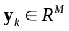 are measurements of M sensors. The ARDLV model is given as [15]
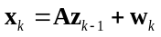 (1)
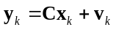 (2)
where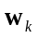 and 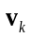are represented as the dynamic and structured white noises following Gaussian distributions with corresponding variance and , respectively. 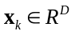comprises D dynamic latent variables. The time lagged vector 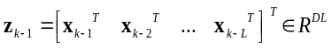 contains several past values of 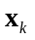. By initializing 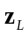 to a Gaussian distribution as 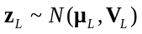, it ensures that the subsequent DLVs will also be Gaussian distributed and can be derived straightforward. Then, the state space matrix 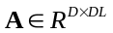can construct the inherent dynamic relationships, while the loading matrix 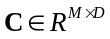 transmits the dynamic relationships to the observation space.
ARDLV model has been proven efficient to extract dynamic and static relationship simultaneously. However, the observations are collected in the complex environment. Usually, the non-Gaussian noises are contained. Meanwhile, there are also some missing values in the measurements. Hence, a robust DLV model is proposed in the next section, which can separate the non-Gaussian disturbance of the measurements in incomplete datasets and estimate the missing values recursively during the modeling process.

- Robust Dynamic Latent Variable Model
In this section, we propose a robust dynamic latent variable (RDLV) model, which is designed for handling datasets characterized by auto-correlation, missing values, and the presence of non-Gaussian noise. Initially, a data processing method is designed, which applies ICA-based model to extract non-Gaussian noises. Following this, the residuals derived from ICA are further utilized to identify the auto-correlations present in the data. Notably, a recursive algorithm is employed to re-estimate the missing values, enhancing the precision and efficiency of the overall model.
- Data Processing for Incomplete Dataset
Assume that an incomplete observed dataset 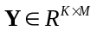 is collected, where several values are missing and denoted as . After removing all of these missing samples, we can obtain the normal dataset 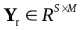. These two datasets are provided as follows.
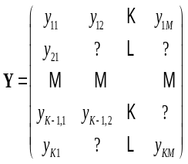 (3) 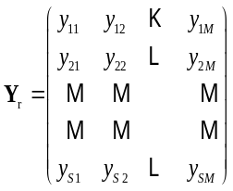 (4)
where is the number of samples, and equals to remaining samples excluding the missing samples. Then, PCA model is constructed on 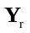 to obtain its loading matrix 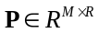 and R is the dimension of the latent variables. To impute the missing values 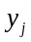 from a sample 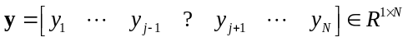, we can firstly estimate the score vector utilizing these non-missing values of the sample 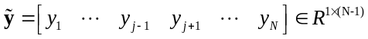 as follows.
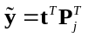 (5)
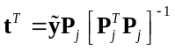 (6)
where 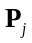 is the loading matrix removing its  row and it is corresponding to the missing data in .
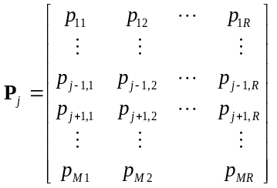 (7)
Then, the value of the missing sample can be estimated by
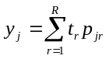 (8)
It is also noticed that multiple values may be absent, but for illustrative purposes, we consider a single missing value in this example. In a similar manner, each missing data point within individual samples can be estimated using the same technique, thereby creating a complete dataset 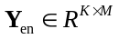.
When the missing values have been provisionally imputed, non-Gaussian noise can be isolated using ICA model. After that, the residuals from the training dataset 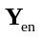 are computed by deflating the data with the extracted independent sources. The mentioned arithmetic formula is given as
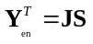 (9)
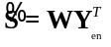 (10)
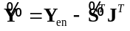 (11)
where represents the independent component, which is associated with a specific mixing matrix and a corresponding demixing matrix.
In summary, the comprehensive procedure for data processing is articulated as follows.

Algorithm 1: Data Processing before RDLV
- Whiten the incomplete training dataset to zero mean and unit variance.
- Remove all of these missing samples to obtain dataset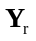.
- Estimate missing values to impute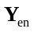by constructing PCA model onusing equations (5) – (8).
- Separate independent components of via (9) – (10).
- Generate residual datasetvia (11) as a new training dataset in the next part for the proposed RDLV model.

- Parameters learning in RDLV
Upon completion of the data processing, non-Gaussian noises are identified and isolated. Subsequently, the task of extracting auto-correlations is undertaken. Concurrently, it also becomes possible to refine the estimation of the missing values.
The residual dataset, denoted as 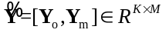, is comprised of both observed measurements and missing values, where 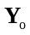 are the Gaussian residuals of observed measurements and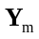 signifies the Gaussian residuals associated with the initial missing values. It is noticed that can be subject to further estimation, as their accuracy was not fully ensured during the data processing phase. To address this, we have developed a recursive method called robust DLV model. This approach enables an alternate estimation of both the missing values and the model parameters. The model structure is outlined in detail below.
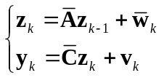 (12)
where the definitions of transition matrix and loading matrix are rewritten as 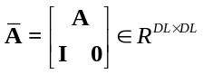, 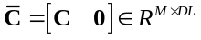, respectively. Meanwhile, the white Gaussian noise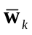 is adapted to follow the new variance 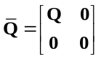, in which 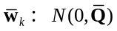. Another structured residual 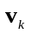 remains the original distribution as 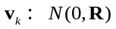. The specified conditions suggest that the initial prior distribution of 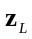 adheres to a Gaussian distribution with 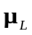 as the mean and 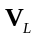 as the variance. Subsequently, it should be noted that the parameters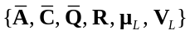 in Eq. (12) require to be estimated. In the following section, we provide a comprehensive outline of the utilization of the Expectation-Maximization (EM) algorithm, which comprises the E-step and M-step.
In the E-step, the objective is to compute the posterior distribution of the hidden variables and the expected joint log likelihood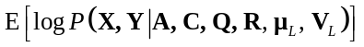. The calculation relies on three crucial expectations: 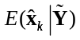, 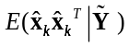, 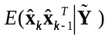.By applying the Kalman filter equations, we are able to accurately determine the state estimation, as shown below.
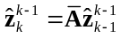 (13)
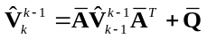 (14)
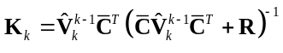 (15)
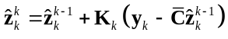 (16)
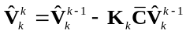 (17)
where we denote 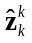and 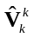as 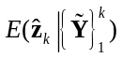and 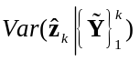, respectively. Likewise, using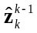 to denote 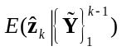 and 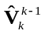to denote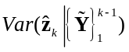, which are the expected quantities from one-step prediction results. 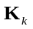 is Kalman gain matrix.
Aiming to estimate the marginal distribution for 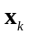 conditionally given all measurements 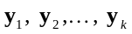, we can acquire the estimated variance and mean from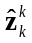and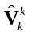. With their convenient structure as
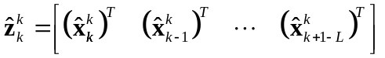 (18)
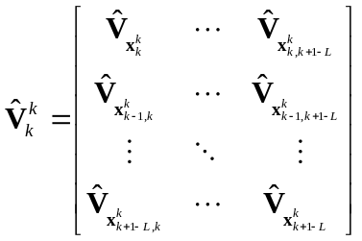 (19)
where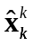and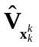 are corresponding to 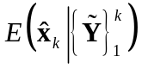and 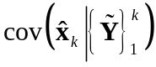.
In the M-step, the entire parameter set is updated by maximizing the joint log likelihood, which is calculated as
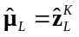 (20)
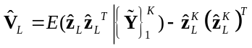 (21)
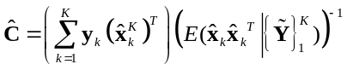 (22)
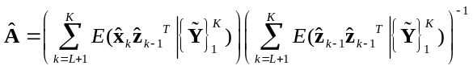 (23)
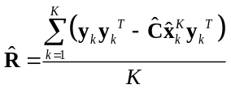 (24)
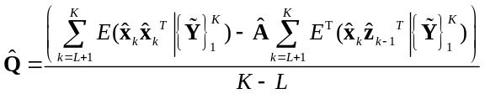 (25)
The detailed derivations of calculation can be referred in [15]. Through the iterative execution of these two steps, the model parameter set will gradually converge to a certain extent.
In order to enhance performance in scenarios where missing observations are present, we have devised an innovative manner that employs a recursive training strategy. It has been observed that the Kalman filter is equivalent to a precise one-step predictor. This implies that the missing values can be re-estimated after the convergence of the iteration using 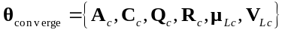. Rather than solely relying on the estimated missing values obtained during the data processing stage, we employ this approach to re-estimate more precise missing values when the parameters are provisionally determined through a converged EM algorithm. Following the well-established principles of the Kalman filter, the missing data points can be estimated as follows.
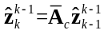 (26)
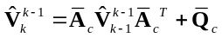 (27)
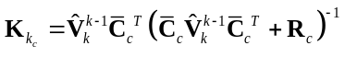 (28)
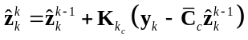 (29)
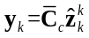 (30)
Subsequently, we need to continue the iterative process of estimating and updating the missing values alternately using equations (26) through (30), until the parameter set reaches a state of near-stability between two consecutive EM algorithms.
In summary, the defined RDLV model can be outlined with the following pseudocode.

Algorithm 2: Parameters Learning in ICA-recursive ARDLV
- Normalize the residual datasetfrom data processing part.
- Initialize the parametersof the dynamic latent variables randomly.
- In the E-step, calculate three expectations: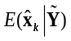，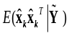, 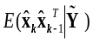 of DLVs to compute the joint log likelihood using equations (13) – (19).
- In the M-step, learn the model parameter via (20) – (25) with the estimating outcomes from E-step.
- If the change of joint log likelihood is smaller than a specified threshold, go to next step. Otherwise, return to Step3.
- Re-estimate the missing values using the parameters obtained in Step 5 in order to reconstruct the training dataset.
- Calculate the deviation between the estimated parameter sets from two consecutive EM algorithms, comparing the values obtained previously and currently. If the parameter set has converged, proceed to the online monitoring phase. Otherwise, return to Step 3 to relearn the parameters.

- Dynamic Process Monitoring based on RDLV Model
In this section, we employ an online process monitoring method predicated on the Robust Dynamic Latent Variable Model. The objective of the proposed method is to scrutinize and interpret the operational status within continuous industrial processes through monitoring of observation variables. In order to accommodate the influence of autocorrelation within dynamic data, we use a specified approach to T² and SPE statistics, which effectively eliminates the issue of fault smearing.
The RDLV model is established upon a historical dataset amassed during periods of standard operating conditions. Subsequent measurements are compared against this well-defined 'normal' benchmark. Contrasting with conventional methods used for static models, we utilize the estimation errors of RDLVs and the residuals from measurements to derive the T² and SPE statistics as outlined below.
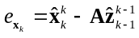 (31)
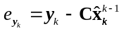 (32)
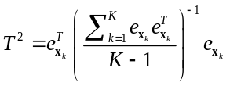 (33)
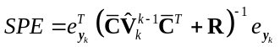 (34)
Table1: Process Fault Description of Numerical Example
Number | Fault description | Fault type | Time duration
1 | 1st DLV | Step change by 0.8 | 1001-1500
2 | 2st DLV | Ramp change by 0.002 * (1000 - t) | 1001-2000
3 | 1st variable | Random change by adding a random variable with N (0; 0.8) | 1001-1500
4 |  | Structure change by changing matrix D | 1001-2000
5 |  | Introduce non-Gaussian disturbance | 1001-1500
Table2: Missing Detection Rate of Numerical Example with 5% Missing Values
5% Missing | RDLV |  | ARDLV |  | DARDLV |  | PCA |  | ICA
Fault Number | T² | SPE | T² | SPE | T² | SPE | T² | SPE | I²
1 | 0.098 | 0.122 | 0.252 | 0.284 | 0.261 | 0.381 | 0.302 | 0.624 | 0.459
2 | 0.239 | 0.271 | 0.305 | 0.348 | 0.271 | 0.336 | 0.396 | 0.543 | 0.472
3 | 0.627 | 0.569 | 0.553 | 0.67 | 0.542 | 0.613 | 0.438 | 0.662 | 0.385
4 | 0.305 | 0.243 | 0.347 | 0.419 | 0.357 | 0.438 | 0.573 | 0.534 | 0.498
5 | 0.067 | 0.08 | 0.211 | 0.286 | 0.238 | 0.319 | 0.346 | 0.471 | 0.379

where 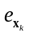is independent variables with the previous dynamic variance regarded as the innovation of DLVs and 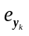is the estimating error of Kalman filter. Hence, the T² and SPE statistics can reveal the correct autocorrelation and
cross-correlation about fault without smearing from previous observation.
For the purpose of process monitoring, the corresponding control limits employed in RDLV are demanded. The control limit of T² and SPE are approximated by the 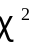distribution as
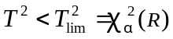 (35)
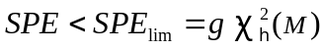 (36)
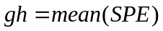 (37)
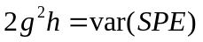 (38)
where R is the number of DLVs, M is the number of observation samples, and and are the significance level.

- Illustrative Simulations
In this section, we present two simulations aimed at assessing the accuracy and superiority of our proposed method for dynamic process monitoring, particularly in scenarios involving missing samples. The first simulation showcases a hypothetical scenario, enabling a straightforward interpretation of the performance of the RDLV model. The second example is grounded in a real-world wastewater treatment process, serving as empirical evidence of the proposed method's efficacy in practical applications.

- Numerical Case Study
Let us assume the subsequent third-order dynamic system in this numerical example using following equations as
(39)
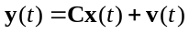 (40)

Table4: Missing Detection Rate of Numerical Example with 15% Missing Values
15% Missing | RDLV |  | ARDLV |  | DARDLV |  | PCA |  | ICA
Fault Number | T² | SPE | T² | SPE | T² | SPE | T² | SPE | I²
1 | 0.147 | 0.169 | 0.435 | 0.617 | 0.537 | 0.603 | 0.774 | 0.765 | 0.589
2 | 0.228 | 0.271 | 0.268 | 0.372 | 0.381 | 0.253 | 0.415 | 0.606 | 0.57
3 | 0.479 | 0.517 | 0.538 | 0.743 | 0.475 | 0.409 | 0.567 | 0.661 | 0.419
4 | 0.337 | 0.312 | 0.446 | 0.426 | 0.394 | 0.515 | 0.599 | 0.634 | 0.617
5 | 0.163 | 0.127 | 0.323 | 0.381 | 0.385 | 0.439 | 0.453 | 0.558 | 0.482
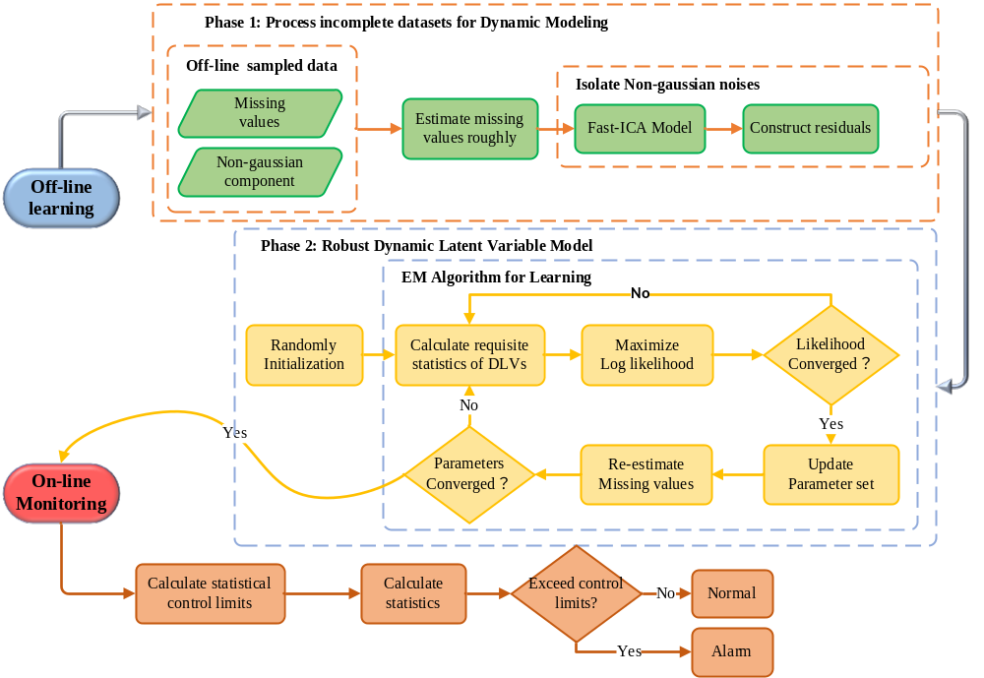
Table3: Missing Detection Rate of Numerical Example with 10% Missing Values
10% Missing | RDLV |  | ARDLV |  | DARDLV |  | PCA |  | ICA
Fault Number | T² | SPE | T² | SPE | T² | SPE | T² | SPE | I²
1 | 0.062 | 0.137 | 0.189 | 0.239 | 0.417 | 0.599 | 0.583 | 0.697 | 0.412
2 | 0.288 | 0.297 | 0.249 | 0.261 | 0.691 | 0.402 | 0.447 | 0.439 | 0.359
3 | 0.503 | 0.674 | 0.541 | 0.652 | 0.673 | 0.461 | 0.436 | 0.574 | 0.389
4 | 0.297 | 0.321 | 0.359 | 0.337 | 0.439 | 0.433 | 0.481 | 0.519 | 0.469
5 | 0.126 | 0.156 | 0.229 | 0.287 | 0.266 | 0.315 | 0.317 | 0.401 | 0.292
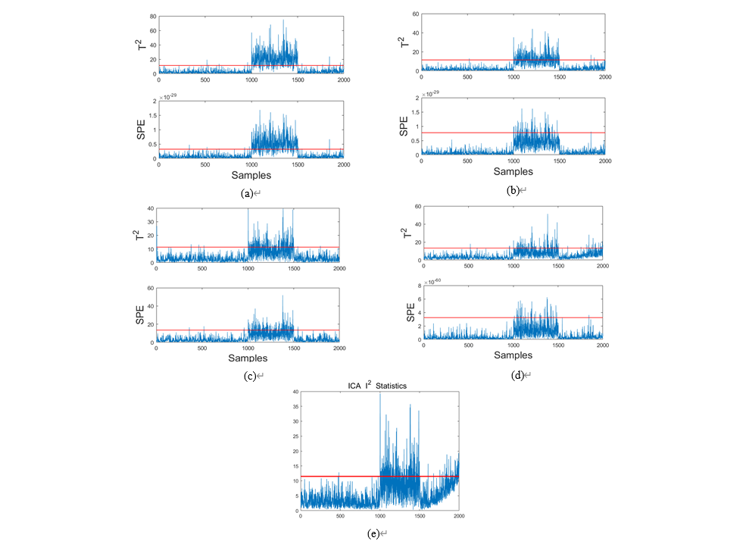
Figure1: Process Monitoring for Fault 1 in the numerical example. (a) ICA-RARDLV. (b) ARDLV. (c) DARDLV. (d) PCA. (e) ICA.

where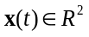is the dynamic latent factor at sampling time t while the corresponding measured variables at the same time are represented by 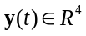. The terms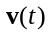and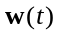 correspond to dynamic evolution and observation noises, respectively. In this article, the dynamic state transition is attached a mixture of sine and cosine signals, which leads to a non-Gaussian disturbance. For model construction, 2000 samples are generated through (39) and (40). To simulate a real industrial process under missing-data conditions, we deliberately omit varying percentages (5%, 10%, 15%) of the measured variables randomly. Furthermore, we introduce five distinct types of faults to disrupt the normal system, as detailed in Table 1. Notably, a non-Gaussian disturbance is introduced, resulting in non-Gaussian Fault 5, which also includes missing values.
To evaluate the efficacy of the proposed monitoring methodology, five distinct testing datasets, each containing the specified fault, are generated for online monitoring. For performance comparison, four alternative models, ARDLV, DARDLV, PCA and ICA are constructed, each utilizing the same dataset. For the proposed method, the time lag of the dynamic system is determined as 3 based on the order of the system and the number of DLVs is determined as 2 according to AIC. Prior to model construction, five alternative methods, inclusive of RDLV, adopt an identical data processing approach as detailed in this article. During the offline learning phase, the Deleting ARDLV (DARDLV) expunges all samples that contain missing values, a common practice when addressing incomplete datasets. In contrast, the ARDLV uses only the data processing method proposed in this article, without revising or updating missing values during the parameter learning process. Lastly, two static methods, PCA and ICA, are examined to demonstrate the dynamic monitoring efficacy of the proposed model.
The fault detection performance of five different models is presented in Table2, 3 and 4, respectively. Using a level of significance of 0.95, the overall missing detection rate is used to summarize the results, considering different environments characterized by varying percentages of missing values (5%, 10%, 15%).
Overall, the proposed process monitoring approach outperforms its alternatives across all evaluated parameters. Notably, even under conditions with a minimal number of missing values (5%), the proposed RDLV model demonstrates considerable superiority over other models.
Importantly, as the percentage of missing values increases (10% or 15%), the RDLV model continues to uphold a low missed detection rate. This underlines the model's adaptability to environments characterized by differing degrees of missing values, as discussed in this paper. In contrast, other missing value estimation methods often oversimplify and overlook the complex interrelationships present in autocorrelated variables. Notably, it is observed that the missed detection rates for ARDLV and DARDLV models rise sharply as the quantity of missing values escalates. Hence, using RDLV method allows for the construction of an accurate dynamic model within an environment with non-Gaussian noise and missing data. To make our analysis more intuitive, we have visualized the simulation results in Figure 1, specifically showcasing Fault 1 with 15% missing values. The proposed RDLV model provides more accurate prediction results and superior process monitoring performance. It is evident that the step fault in the DLV is promptly identified as it occurs at 1000 samples for both T² and SPE statistics. In contrast, the other four alternative models fail to detect faults with the same sensitivity as the RDLV model.
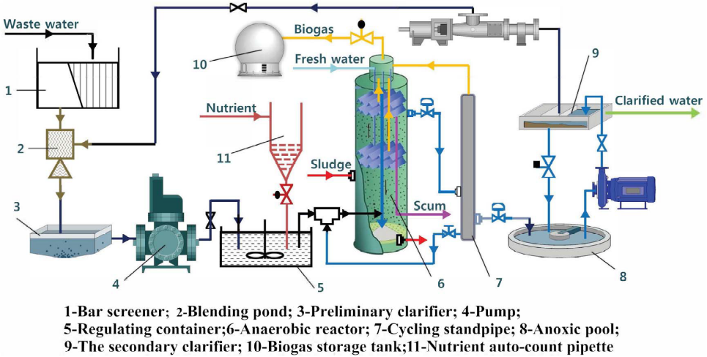
Figure2: Flowchart of the wastewater treatment.
- R2S Anaerobic Reactor Unit in Wastewater Treatment Process
In this subsection, a realistic R2S anaerobic reactor in the papermaking WWTP is further utilized to assess the effectiveness of the proposed RDLV scheme in a practical setting. The primary objective of the WWTP is to transform wastewater generated in papermaking processes into a reusable resource or reintegrate it into the water cycle, thereby minimizing environmental contamination. A typical wastewater treatment plant (WWTP) consists of various components, including a blending pond, clarifier, regulating container, anaerobic reactor, cycling standpipe, biogas tank, and more. A comprehensive depiction of these elements can be found in Figure 2, illustrating the detailed flowchart of the WWTP.
During the treatment process, the initial phase involves eliminating suspended contaminants such as oil slicks and sediments from the wastewater, while also adjusting its pH level. Following this, the effluent undergoes microbial anaerobic and aerobic reactions to promote biodegradation. The goal is to recycle it through secondary sedimentation tanks, sand filtration, and reverse osmosis methods. The strategic use of microbial products designed to enhance water quality significantly reduces sludge production and the concentration of Chemical Oxygen Demand (COD). This not only improves water clarity but also plays a crucial role in mitigating environmental pollution. Given the intricate nature of operational conditions, the unpredictable nature of feed, and the variability of raw materials, wastewater treatment plants (WWTP) usually experience numerous faults.
In this paper, we have selected 12 process variables from two R2S anaerobic reactors for the purpose of process monitoring. Detailed descriptions of these variables can be found in Table 5.
Similar to the numerical example, we simulate an incomplete dataset by randomly eliminating measured values prior to both modeling and monitoring. Then, a total of 1500 samples with missing measurements are used to train the model parameters. Subsequently, two type of process faults are introduced to further assess the efficacy of fault identification. The first fault is observed between the 800th and 1380th samples, while the second is detected between the 360th and 1300th samples. In order to provide a comprehensive analysis, we set a confidence level of 95%. Accordingly, the rates of false alarms and missed detections are meticulously documented in Table 6 and Table 7, respectively.
For both T² and SPE statistics, it is observed that the proposed RDLV model achieves a lower rate of missed detections, even when tested with a range of percentages for missing values. This holds true regardless of whether the number of missing values is minimal or substantial. On the contrary, the ARDLV and DARDLV models exhibit a diminished capacity for monitoring operations based on a real process with missing data.
Tags | Variable Description
XMEAS (1) | the inlet flowrate in R2S-1
XMEAS (2) | the inlet flowrate in R2S-2
XMEAS (3) | the PH of inlet flow in R2S-1
XMEAS (4) | the PH of inlet flow in R2S-2
XMEAS (5) | the water circulation rate in R2S-1
XMEAS (6) | the water circulation rate in R2S-2
XMEAS (7) | the temperature of inlet flow in R2S-1
XMEAS (8) | the temperature of inlet flow in R2S-2
XMEAS (9) | the PH of outlet flow in R2S-1
XMEAS (10) | the PH of outlet flow in R2S-2
XMEAS (11) | the temperature of outlet flow in R2S-1
XMEAS (12) | the temperature of outlet flow in R2S-2
Table5: Fault Description in R2S Reactor Unit

It can be plainly inferred that these models fail to accurately estimate the missing values. Besides, while PCA presents a notably low rate of missed detections, similar to the proposed model, it exhibits a higher rate of false alarms than the RDLV model. Consequently, PCA proves unsuitable for monitoring an actual industrial process. When combining the T² and SPE statistics, the overall performance of the proposed RDLV model surpasses other alternative methodologies. This is due to its unique ability to not only recursively re-estimate missing values, but also to accurately extract both autocorrelation and cross-correlation within the incomplete dataset.

- Conclusion
In this article, a novel robust DLV model is proposed for dynamic process modeling and monitoring purpose in the cyber-physical systems. This novel approach outstrips conventional alternatives by accounting for Gaussian noises in scenarios involving missing values. Besides, the missing data can be recursively re-estimated through one-step predictor of RDLV, which improves the performance of the proposed model in an incomplete observation. Hence, both autocorrelation and cross-correlation are effectively extracted within this complex environment. Finally, the effectiveness of process monitoring is validated through a simulated numerical case and a realistic R2S anaerobic reactor unit in the WWTP. The obtained results demonstrate that the proposed RDLV model excels in effectively addressing the challenges of dynamic process modeling and monitoring, particularly in complex measurement environments where missing values are present. It outperforms several alternative solutions in terms of accuracy and efficiency, providing robust and reliable performance in such intricate scenarios of CPS.
References
- Y. Liu, X. Tao, X. Li, A. Colombo and S. Hu, "Artificial Intelligence in Smart Logistics Cyber-Physical Systems: State-of-The-Arts and Potential Applications," in IEEE Transactions on Industrial Cyber-Physical Systems, doi: 10.1109/TICPS.2023.3283230.
- Z. Ge, Z. Song, and F. Gao, “Review of recent research on databased process monitoring,” Industrial & Engineering Chemistry Research, vol. 52, no. 10, pp. 3543–3562, 2013.
- S. Bersimis, S. Psarakis, and J. Panaretos, “Multivariate statistical process control charts: an overview,” Quality and Reliability Engineering International, vol. 23, no. 5, pp. 517–543, 2007.
- S. Joe Qin, “Statistical process monitoring: basics and beyond,” Journal of Chemometrics, vol. 17, no. 8-9, pp. 480–502, 2003.
- W. Ku, R. H. Storer, and C. Georgakis, “Disturbance detection and isolation by dynamic principal component analysis,” Chemometrics and intelligent laboratory systems, vol. 30, no. 1, pp. 179–196, 1995.
- Z. Ge, “Review on data-driven modeling and monitoring for plant-wide industrial processes,” Chemometrics and Intelligent Laboratory Systems, 2017.
- S. J. Qin, “Survey on data-driven industrial process monitoring and diagnosis,” Annual Reviews in Control, vol. 36, no. 2, pp. 220–234, 2012.
- Q. Chen and U. Kruger, “Analysis of extended partial least squares for monitoring large-scale processes,” IEEE Trans. Control Syst. Technol., vol. 13, no. 5, pp. 807–813, 2005.
- Z. Ge and Z. Song, “Mixture bayesian regularization method of ppca for multimode process monitoring,” AIChE journal, vol. 56, no. 11, pp. 2838–2849, 2010.
- L. H. Chiang, M. E. Kotanchek, and A. K. Kordon, “Fault diagnosis based on fisher discriminant analysis and support vector machines,” Computers & Chemical Engineering, vol. 28, no. 8, pp. 1389–1401, 2004.
- W. Li and S. J. Qin, “Consistent dynamic pca based on errors-in-variables subspace identification,” Journal of Process Control, vol. 11, no. 6, pp. 661–678, 2001.
- A. Simoglou, E. Martin, and A. Morris, “Statistical performance monitoring of dynamic multivariate processes using state space modelling,” Computers & Chemical Engineering, vol. 26, no. 6, pp. 909–920, 2002.
- A. Negiz and A. Çlinar, “Statistical monitoring of multivariable dynamic processes with state-space models,” AIChE Journal, vol. 43, no. 8, pp. 2002–2020, 1997.
- Q. Wen, Z. Ge, and Z. Song, “Data-based linear gaussian statespace model for dynamic process monitoring,” AIChE Journal, vol. 58, no. 12, pp. 3763–3776, 2012.
- G. Li, S. J. Qin, and D. Zhou, “A new method of dynamic latentvariable modeling for process monitoring,” IEEE Transactions on Industrial Electronics, vol. 61, no. 11, pp. 6438–6445, 2014.
- L. Zhou, G. Li, Z. Song, and S. J. Qin, “Autoregressive dynamic latent variable models for process monitoring,” IEEE Transactions on Control Systems Technology, vol. 25, no. 1, pp. 366–373, 2017.
- Zhu Jinlin, Ge Zhiqiang, Song Zhihuan and Gao Furong, "Review and big data perspectives on robust data mining approaches for industrial process modeling with outliers and missing data." Annual Reviews in Control, vol 46, pp . 107-133, 2018.
- Severson, K.A., Molaro, M.C. and Braatz, R.D., “Principal Component Analysis of Process Datasets with Missing Values,” Processes, vol 5, no. 3, pp. 38, 2017.
- Tao Chen, and Yue Sun, "Probabilistic contribution analysis for statistical process monitoring: A missing variable approach." Control Engineering Practice, vol. 17, no.4, pp. 469-477,2008.
- J. Fan, T. W. S. Chow and S. J. Qin, "Kernel-Based Statistical Process Monitoring and Fault Detection in the Presence of Missing Data," in IEEE Transactions on Industrial Informatics, vol. 18, no. 7, pp. 4477-4487, 2022.
- Q. Jiang, X. Yan and B. Huang, "Neighborhood Variational Bayesian Multivariate Analysis for Distributed Process Monitoring With Missing Data," in IEEE Transactions on Control Systems Technology, vol. 27, no. 6, pp. 2330-2339, 2019.
- Lijia Luo, Shiyi Bao and Xin Peng, “Robust monitoring of industrial processes using process data with outliers and missing values,”Chemometrics and Intelligent Laboratory, vol 192, 2019.
- Q. Dai, C. Zhao and S. Zhao, "Variational Bayesian Student’s-t Mixture Model With Closed-Form Missing Value Imputation for Robust Process Monitoring of Low-Quality Data," IEEE Transactions on Cybernetics, 2022.
- Ge, Zhiqiang and Zhihuan Song, “Process Monitoring Based on Independent Component Analysis - Principal Component Analysis (ICA - PCA) and Similarity Factors.” Industrial & Engineering Chemistry Research, vol 46, pp. 2054-2063, 2007.
- Y. Xu, S. -Q. Shen, Y. -L. He and Q. -X. Zhu, "A Novel Hybrid Method Integrating ICA-PCA With Relevant Vector Machine for Multivariate Process Monitoring," in IEEE Transactions on Control Systems Technology, vol. 27, no. 4, pp. 1780-1787, July 2019.
- Jian Huang and Xuefeng Yan, “Gaussian and non-Gaussian Double Subspace Statistical Process Monitoring Based on Principal Component Analysis and Independent Component Analysis”. American Chemical Society, vol 54, no. 3, pp/ 1015-1027, 2018.
- J. Zhu, Z. Ge and Z. Song, "Non-Gaussian Industrial Process Monitoring With Probabilistic Independent Component Analysis," in IEEE Transactions on Automation Science and Engineering, vol. 14, no. 2, pp. 1309-1319, April 2017.
- Mudassir M. Rashid,Jie Yu, “A new dissimilarity method integrating multidimensional mutual information and independent component analysis for non-Gaussian dynamic process monitoring” Chemometrics and Intelligent Laboratory Systems, vol 115, pp. 44-58, 2012.
- Li Shuai,Zhou Xiaofeng,Shi Haibo,Pan and Fucheng, “Dynamic Non-Gaussian Hybrid Serial Modeling for Industrial Process Monitoring”.Chemometrics and Intelligent Laboratory Systems, vol 216, 2021.

Table6: Missing Detection Rate of R2S Reactor Unit with 1%, 5%, 10% Missing Values
Missing Percent | Fault Number | RDLV |  | ARDLV |  | DARDLV |  | PCA |  | ICA
Missing Percent | Fault Number | T² | SPE | T² | SPE | T² | SPE | T² | SPE | I²
1% | 1 | 0.024 | 0.017 | 0.795 | 0.016 | 0.662 | 0.172 | 0.012 | 0.753 | 0.48
1% | 2 | 0.178 | 0.051 | 0.733 | 0.119 | 0.732 | 0.015 | 0 | 0.691 | 0.276
5% | 1 | 0.076 | 0.012 | 0.179 | 0.281 | 0.912 | 0.016 | 0.043 | 0.764 | 0.967
5% | 2 | 0.169 | 0.005 | 0 | 0.272 | 0.947 | 0.003 | 0.051 | 0.56 | 0.98
10% | 1 | 0.019 | 0.019 | 0.259 | 0.997 | 0.874 | 0.021 | 0.074 | 0.79 | 0.998
10% | 2 | 0.078 | 0.072 | 0.162 | 1 | 0.89 | 0.013 | 0.16 | 0.56 | 1
Table7: False Alarm Rate of R2S Reactor Unit with 1%, 5%, 10% Missing Values
Missing Percent | Fault Number | RDLV |  | ARDLV |  | DARDLV |  | PCA |  | ICA
Missing Percent | Fault Number | T² | SPE | T² | SPE | T² | SPE | T² | SPE | I²
1% | 1 | 0.12 | 0.096 | 0.135 | 0.07 | 0.108 | 0.074 | 0.145 | 0.078 | 0.01
1% | 2 | 0.086 | 0.091 | 0.164 | 0.095 | 0.105 | 0.145 | 0.291 | 0.138 | 0.1
5% | 1 | 0.085 | 0.134 | 0.12 | 0 | 0.038 | 0.122 | 0.132 | 0.047 | 0
5% | 2 | 0.086 | 0.064 | 0.245 | 0 | 0.064 | 0.077 | 0.193 | 0.161 | 0
10% | 1 | 0.082 | 0.037 | 0.05 | 0 | 0.015 | 0.047 | 0.088 | 0.068 | 0
10% | 2 | 0.07 | 0.005 | 0.12 | 0 | 0.145 | 0.145 | 0.093 | 0.161 | 0.14

 

